Lab 7 DTMF Tone Generation and Detection Using Goertzel Algorithm

OBJECTIVES
- To learn how to generate DTMF tones
- To learn how to perform DTMF detection using the Goertzel algorithm.

PROCEDURE:

Part A: DTMF Tone Generation
The DTMF tone generator uses two digital filters in parallel each using the impulse sequence as an input. The filter for the DTMF tone for key “7” is depicted below.

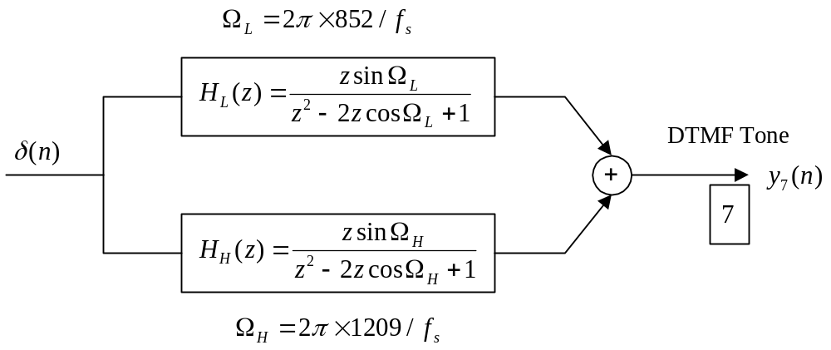
Figure 1. Digital DTMF tone generator for the digit “7”.

The industry standard frequency specifications for all the keys are listed in Figure 2.
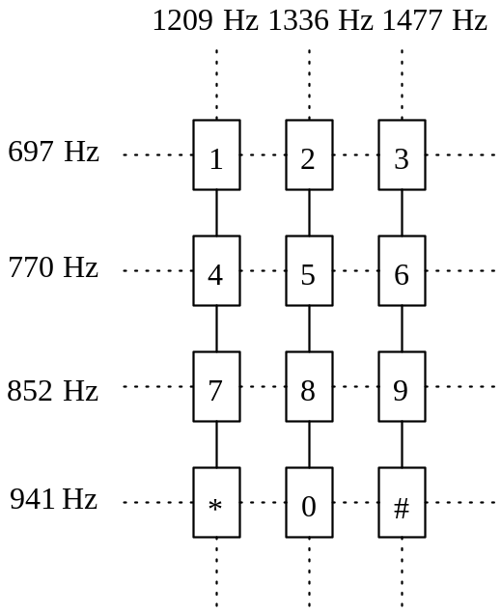

Figure 2 DTMF tone specifications.

According to the DTMF tone specification, develop the MATLAB program that will be able to generate each tone.

Instructor verification __________________________

Part B: DTMF detection
The DTMF detection relies on the Geortzel algorithm (Geortzel filter). The main purpose of using the Goertzel filters is to calculate the spectral value at the specified frequency index using the filtering method. Its advantage includes the reduction of the required computations and avoidance of complex algebra. The seven modified Goertzel filters are implemented in parallel shown in Figure 3. As shown in Figure 3, the output from each Goertzel filter is fed to its detector to compute its spectral value, which is given by
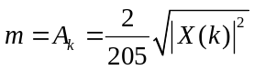
Each calculated spectral value is compared to a specified threshold value. If the detected value is larger than the threshold value, the logic operation outputs the logic 1 otherwise it outputs the logic 0. Then the logic operation at the last stage is to decode the key information based on the 7-bit binary pattern.

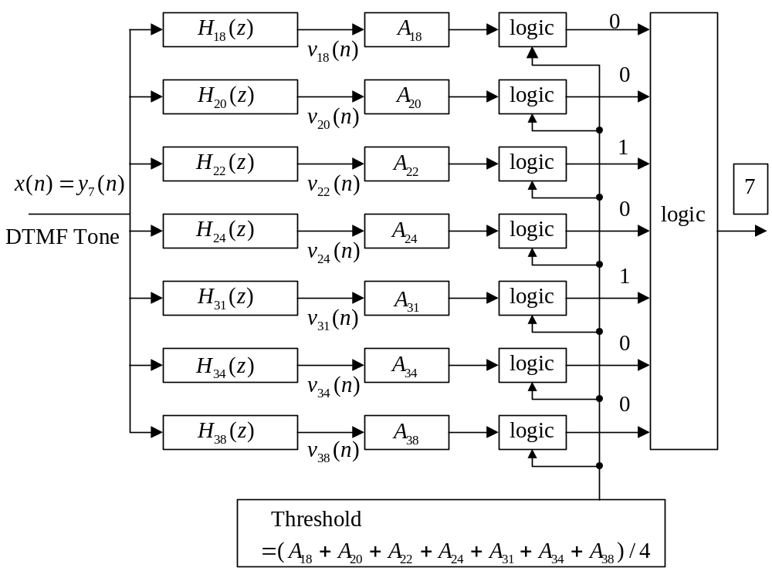

Figure 3 DTMF tone detector.

Write a MATLAB program to perform detection and display each detected key on the screen.

Instructor verification __________________________
Keys to Lab 7
close all;clear all
figure(1)
% DTMF tone generator
fs=8000;
t=[0:1:204]/fs;
x=zeros(1,length(t));
x(1)=1;
y852=filter([0 sin(2*pi*852/fs) ],[1 -2*cos(2*pi*852/fs) 1],x);
y1209=filter([0 sin(2*pi*1209/fs) ],[1 -2*cos(2*pi*1209/fs) 1],x);
y7=y852+y1209;
subplot(2,1,1);plot(t,y7);grid
ylabel('y(n) DTMF: number 7');
xlabel('time (second)')
Ak=2*abs(fft(y7))/length(y7);Ak(1)=Ak(1)/2;
f=[0:1:(length(y7)-1)/2]*fs/length(y7);
subplot(2,1,2);plot(f,Ak(1:(length(y7)+1)/2));grid
ylabel('Spectrum for y7(n)');
xlabel('frequency (Hz)');

figure(2)
% DTMF detector (use Goertzel algorithm)
b697=[1];
a697=[1 -2*cos(2*pi*18/205) 1];
b770=[1];
a770=[1 -2*cos(2*pi*20/205) 1];
b852=[1];
a852=[1 -2*cos(2*pi*22/205) 1];
b941=[1];
a941=[1 -2*cos(2*pi*24/205) 1];
b1209=[1];
a1209=[1 -2*cos(2*pi*31/205) 1];
b1336=[1];
a1336=[1 -2*cos(2*pi*34/205) 1];
b1477=[1];
a1477=[1 -2*cos(2*pi*38/205) 1]

[w1, f]=freqz([1 -exp(-2*pi*18/205)],a697,512,8000);
[w2, f]=freqz([1 -exp(-2*pi*20/205)],a770,512,8000);
[w3, f]=freqz([1 -exp(-2*pi*22/205)],a852,512,8000);
[w4, f]=freqz([1 -exp(-2*pi*24/205)],a941,512,8000);
[w5, f]=freqz([1 -exp(-2*pi*31/205)],a1209,512,8000);
[w6, f]=freqz([1 -exp(-2*pi*34/205)],a1336,512,8000);
[w7, f]=freqz([1 -exp(-2*pi*38/205)],a1477,512,8000);
subplot(2,1,1);plot(f,abs(w1),f,abs(w2),f,abs(w3), ...
f,abs(w4),f,abs(w5),f,abs(w6),f,abs(w7));grid
xlabel('Frequency (Hz)');
ylabel('BPF frequency responses');

yDTMF=[y7 0];
y697=filter(1,a697,yDTMF);
y770=filter(1,a770,yDTMF);
y852=filter(1,a852,yDTMF);
y941=filter(1,a941,yDTMF);
y1209=filter(1,a1209,yDTMF);
y1336=filter(1,a1336,yDTMF);
y1477=filter(1,a1477,yDTMF);

m(1)=sqrt(y697(206)^2+y697(205)^2- ...
2*cos(2*pi*18/205)*y697(206)*y697(205));
m(2)=sqrt(y770(206)^2+y770(205)^2- ...
2*cos(2*pi*20/205)*y770(206)*y770(205));
m(3)=sqrt(y852(206)^2+y852(205)^2- ...
2*cos(2*pi*22/205)*y852(206)*y852(205));
m(4)=sqrt(y941(206)^2+y941(205)^2- ...
2*cos(2*pi*24/205)*y941(206)*y941(205));
m(5)=sqrt(y1209(206)^2+y1209(205)^2- ...
2*cos(2*pi*31/205)*y1209(206)*y1209(205));
m(6)=sqrt(y1336(206)^2+y1336(205)^2- ...
2*cos(2*pi*34/205)*y1336(206)*y1336(205));
m(7)=sqrt(y1477(206)^2+y1477(205)^2- ...
2*cos(2*pi*38/205)*y1477(206)*y1477(205));
m=2*m/205;
th=sum(m)/4; %based on empirical measurement
f=[ 697 770 852 941 1209 1336 1477];
f1=[0 4000];
th=[ th th];
x
subplot(2,1,2);stem(f,m);grid
hold; plot(f1,th);
xlabel('Frequency (Hz)');
ylabel('Absolute output values');

